WOMEN AND THE FIGHT FOR OUR HABITAT RIGHTS AND SOCIAL JUSTICE
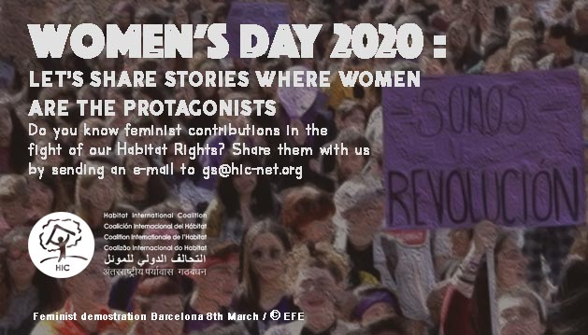

INFO | GUIDELINES
TESTIMONIAL  Please share the story of a woman or group of women where she or they are the protagonist in the fight for our habitat rights or social justice | Who is she/them? If possible share the background and the current context of her /their work/fight.  Include some info of the context where she/they live: country, city, community, situation, threats to her/their rights…  Extension: 300- 500 words is enough but if you have more info don’t hesitate to share it as well
Related info | Share links if possible to your website or another info related to the story: news,papers social media accounts, images, videos…
Organization | Share the role of your organization in this story and the info:  Website  Social media accounts
Images, videos | If possible: share images and videos that illustrate the story
Logos | Share your logo and we will add it to the story

